**Call center outgoing calls (Marketing)**

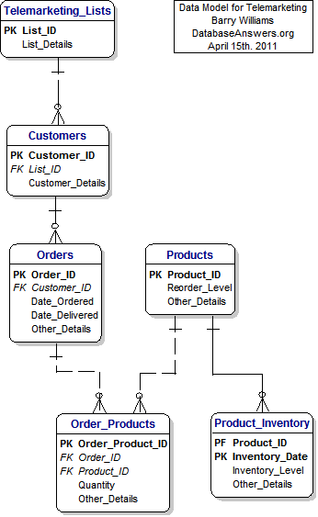

**SQL Questions:**

1. **Which list has most number of customers?**
2. **What is the average orders we place in a week?**
3. **Find out all the orders which took more than a week for the delivery.**
4. **Find the inventory date which has more inventory level for each product.**
5. **On a given day ’10-JAN-11’ which order has most number of products placed.**
6. **Expand the customer table with more than 8 columns based on your knowledge.**
7. **Expand the product table with more than 6 columns based on your knowledge.**
8. **Expand this model to include the employee information and track the employee orders. After modifying the model, we should be able to find the top employees in terms of sales.**
9. **Create a materialized view which has customer_id, customer name, product name, week_yy, total quantity.**
10. **What is the use of reorder_level column in the product table?**
11. **Include the supplier in this model, they will have to be associated to set of products where they can supply. Certain products can be provided by certain suppliers.**